traad  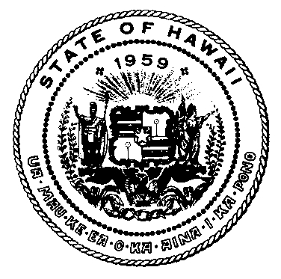 | DISABILITY AND COMMUNICATION ACCESS BOARD
919 Ala Moana Boulevard, Room 101 • Honolulu, Hawaii 96814
Ph. (808) 586-8121 (V/TDD) • Fax (808) 586-8129

AMENDED AGENDA
  - Legislative Committee Meeting
Location: Disability and Communication Access Board
919 Ala Moana Blvd., Room 103
Date: March 1, 2017
Time: 12:00 p.m.

Call to Order

Introductions

Approval of February 22, 2017 Meeting Minutes

Legislative Strategy/Positions Relating to Bills

Parking for Persons with Disabilities

- Nondiscrimination Against Persons with Disabilities/Civil Rights
- HB 1518 – Relating to Public Records
Provides that upon request from a public agency, OIP may under certain conditions declare a person a vexatious records requester and restrict the person's rights under the Uniform Information Practices Act. Establishes processes to appeal the declaration of a person as a vexatious records requester. Repeals on June 30, 2020.
- HB 1489, HD1 – Relating to Civil Rights
Prohibits a state agency or program or activity receiving state financial assistance from excluding from participation, denying benefits to, or discriminating against a qualified individual by reason of disability, sex, including gender identity or expression, or sexual orientation.

- Service Animals for Persons with Disabilities

- Building Code/Design

- Community Based Services for Persons with Disabilities – Non-appropriation
- SB 798 – Relating to Telecommuting
Establishes a temporary telecommuting task force to develop incentives and recommendations to encourage and expand telecommuting opportunities in the public and private sectors.
- SCR 56 – Requesting the Auditor to Conduct a Study to Assess the Impact of Using Medicaid Funds to Provide Coverage for the Treatment for Homelessness

- Community Based Services for Persons with Disabilities – Appropriation

G. Administrative/Other

Legislative Updates

Status on Bills with DCAB Positions
- SB 27 – Making an Appropriation to Restore Adult Basic Dental Benefits to Medicaid Enrollees
Makes an appropriation to the department of human services to restore basic adult dental benefits to Medicaid enrollees. Requires the department of human services to obtain the maximum federal matching funds available for this expenditure.
- SB 1277, SD1 – Relating to Public Agency Meetings
Allows the minutes at public agency meetings to be kept by written or recorded means.
- SB 535, SD1 – Relating to Hearing Aids
Requires health insurance policies and contracts issued after 12/31/18 to provide coverage for the cost of hearing aids at a minimum of $1,500 per hearing aid for each hearing impaired ear every thirty-six months.
- SB 974, SD1 – Relating to Parking for Disabled Persons
Limits the exemption from payment of parking meter fees to vehicles that display a distinguishing parking permit or decal issued to an applicant who presents a certificate of disability that verifies that the applicant is licensed to drive a motor vehicle and cannot reach or operate a parking meter because of a physical disability. Takes effect 7/1/2018.
- HB 475, HD1 – Relating to Movie Theaters
Extends the sunset date of Act 39, Session Laws of Hawaii 2015, which requires certain motion picture theaters to provide open movie captioning and audio description for certain motion pictures at certain times. Requires DBEDT to conduct an impact survey.
- HCR 33 – Requesting the Auditor to Conduct a Sunrise Review of the Licensure and Regulation of Gerontologists

Open Forum
Public comment on issues not on the agenda, for consideration for Committee’s agenda at the next meeting

- Next Meeting
Wednesday, March 8, 2017 at 12:00 p.m. at 919 Ala Moana Boulevard, room 103

- Adjournment

If you require an auxiliary aid or accommodation due to a disability, please contact (808) 586-8121 (voice/tty) or email at dcab@doh.hawaii.gov by February 24, 2017.

